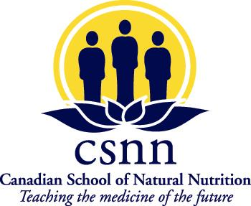
O1
Application Form – Enhanced Diploma in Natural Nutrition with Clinical Studies

1201 Mountain Rd, Suite 205 Moncton, NB., E1C 2T4

(506) 384 2700

Name:

Address:
City/Province |  |  | Postal Code |  |  |  |  |  | Birth date:
Date of application |  |  | Email
Day phone number |  |  | Evening phone number

Name of next of kin, address and phone number

Social Insurance Number (for tuition tax receipt purposes)
ATTACHED IS PROOF OF EDUCATION: GRADE 12 DIPLOMA_____, GED GRADE 12 EQUIVALENT:____,

HIGH SCHOOL COMPLETION CERTIFICATION:____ OR: SIGNED AND SEALED GRADE 12 TRANSCRIPT:______
Please enclose with this application a non-refundable registration fee of $100.00 payable to The Canadian School of Natural Nutrition.
Start Date: Wednesday, October 2nd, 2024 (Orientation Oct. 1st)

Briefly describe your goals and interests in relation to the program (you may use extra paper if required):

We will contact you to arrange an appointment upon receipt of your application form and proof of education

Upon acceptance, we will require a deposit of $800 for Module 1 payable to the Canadian School of Natural Nutrition. This deposit is to reserve your placement in the program and will be refundable when notice is given of non-attendance. See our refund policy for details.
Acceptance letter sent:  Interview Date: |  |  |  |  | $100 application fee received:  Module I deposit received:
Accepted by: |  |  |  |  | Date:
COURSE TUITION for the ENHANCED PROGRAM is $11,280.00
Your deposit will be applied to the first payment.
 |  | Tuition |  |  |  |  |  | 1-year day program
 | 1st payment | 3720.00 |  |  |  |  |  | On start date
 | 2nd payment | 2520.00 |  |  |  |  |  | December 1st
 | 3rd payment | 2520.00 |  |  |  |  |  | February 1st
 | 4th payment | 2520.00 |  |  |  |  |  | April 1st
Student Protection fee (1% of tuition fee): $112.80
*BOOKS ARE EXTRA AND APPROXIMATE COST -$925
REQUIREMENTS
I understand that, in addition to the classroom studies in which I must maintain an average of 80% and 10 case studies must be completed before the final written examination date to meet the CSNN requirements to graduate.
CONFIDENTIALITY and DISCLOSURE
Absolutely no part of the content in the copyrighted publications, course material or teachers notes, may be photocopied or adapted for teaching purposes or shared with anyone not taking the CSNN program. Breach of these restrictions will result in legal action
 | Signature |  |  |  |  | Date

